Problem we find:

The problem we find is like this:

When we use the following code to generate a key in two different project the key in one project never change, but another one always changes:
initKey = "2011BCSChampion-AuburnUniversity";
KeyGenerator generator = KeyGenerator.getInstance("AES"); SecureRandom secureRandom = new SecureRandom(initKey.getBytes());
generator.init(256,secureRandom);
SecretKey Key1 = generator.generateKey();
SecretKey Key2 = generator.generateKey();
System.out.println("Using Key1: ");
for (byte b : Key1.getEncoded()) {
System.out.format("%02x", b);
}
System.out.println("Using Key2: ");
for (byte b : Key2.getEncoded()) {
System.out.format("%02x", b);
}

Key1 and key2 is in the same project, they are different but no matter how many time we run they always are same as before.

Just like this
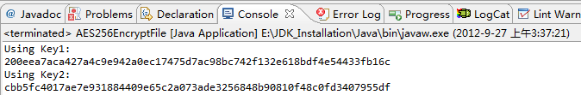
Figure 1
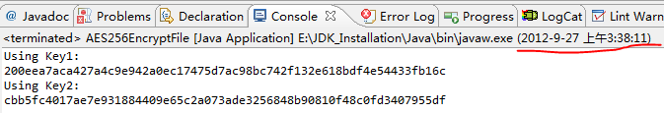
Figure 2

We think it may be caused by the secure random number, so we print out the secure random number:

System.out.println("random" + secureRandom.nextInt());
System.out.println("random" + secureRandom.nextInt());

And we find the secure random number also never change likes this:

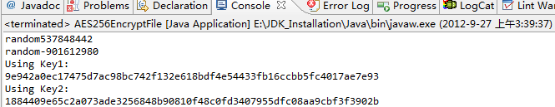
Figure 3
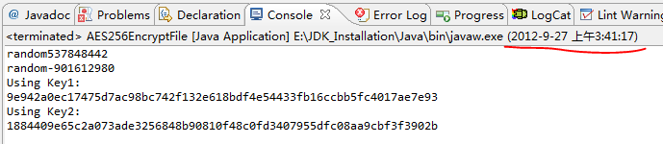
Figure 4
And we print out the algorithm and provider of the secure random number
System.out.println("Provider " + ecureRandom.getProvider().getName());
System.out.println("algorithm" + secureRandom.getAlgorithm());

It show like this
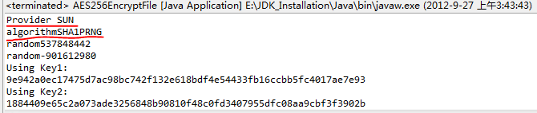
Figure 5
So we think it is caused by the algorithm we use to generate the secure random number. To test our guess, we print out the algorithm and provider of second project which can generate random key.
String InitialKey = "2011BCSChampion-AuburnUniversity";
KeyGenerator keyGen = KeyGenerator.getInstance("AES");
SecureRandom secureRandom = new SecureRandom(InitialKey.getBytes());
System.out.println("Provider " + secureRandom.getProvider().getName());
System.out.println("algorithm:" + secureRandom.getAlgorithm());
System.out.println("random" + secureRandom.nextInt());
System.out.println("random" + secureRandom.nextInt());
keyGen.init(256,secureRandom);
SecretKey key = keyGen.generateKey();

The result is like this:
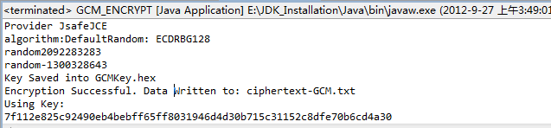
Figure 6
Run it again
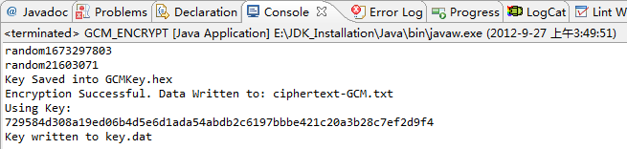
Figure 7
As we can see the random number and generated key have changed, so we guess the problem is caused by the algorithm we using to generate the SecureRandom object.

Why the default provider and algorithm is different?
We print out the provider list of this two:
The first one is:
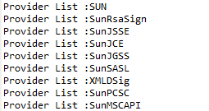
The second one is:
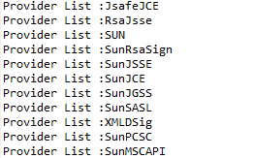

And we find in the second project we import two external library,
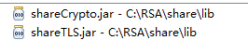
Figure 8
But in the first project we do not.

So it is the reason why the default provider and default algorithm is different.

What will happen if we use the algorithm of "SHA1PRNG" in second project
String InitialKey = "2011BCSChampion-AuburnUniversity";
KeyGenerator keyGen = KeyGenerator.getInstance("AES");
SecureRandom secureRandom = SecureRandom.getInstance("SHA1PRNG");
secureRandom.setSeed(InitialKey.getBytes());
System.out.println("Provider"+ secureRandom.getProvider().getName());
System.out.println("algorithm:" + secureRandom.getAlgorithm());
System.out.println("random" + secureRandom.nextInt());
System.out.println("random" + secureRandom.nextInt());

Result
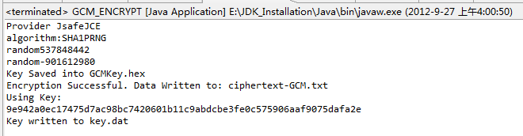
Figure 9

As we can see the first two random number and key are same as those in figure 3.

Conclusion

So the problem we find is cause by the algorithm "SHA1PRNG" we using to generate the SecureRandom object, because it is just a pseudo-random number generation (PRNG) algorithm, so if we use the same seed in this algorithm, we will alway get same sequence of number, this is way we always get the same key when we run the project again and again.

Solution to this problem

- One solution is importing external library and use the external provider's algorithm
- Use random seed instead of fixed seed
- Another is use another algorithm. We can find the algorithm by this way
Run this code:
for(int n =0; n<Security.getProviders().length;n++)
{
System.out.println("Provider List :" + Security.getProviders()[n].getName());
System.out.println("ProviderServiceList:"+Security.getProviders()[n].getServices());}

We will get a Provider Service List like this
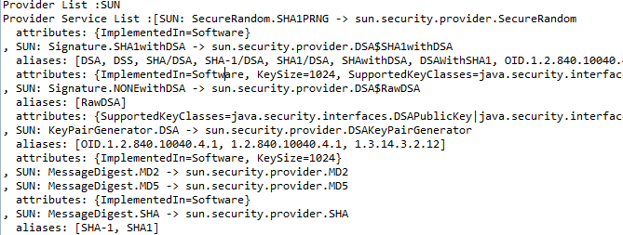
Figure 10
And we can use ctrl + F to search search SecureRandom, we can find algorithm "SHA1PRNG" provided by Sun and "Windows-PRNG" provided by SunMSCAPI

We can use the algorithm "Windows-PRNG" to avoid this problem
initKey = "2011BCSChampion-AuburnUniversity";
KeyGenerator generator = KeyGenerator.getInstance("AES");
SecureRandom secureRandom = SecureRandom.getInstance("Windows-PRNG");
secureRandom.setSeed(initKey.getBytes());
System.out.println("Provider " + secureRandom.getProvider().getName());
System.out.println("algorithm" + secureRandom.getAlgorithm());
System.out.println("random" + secureRandom.nextInt());
System.out.println("random" + secureRandom.nextInt());
generator.init(256,secureRandom);
SecretKey Key1 = generator.generateKey();
SecretKey Key2 = generator.generateKey();
System.out.println("Using Key1: ");
for (byte b : Key1.getEncoded()) {
System.out.format("%02x", b);
}

Here is the result
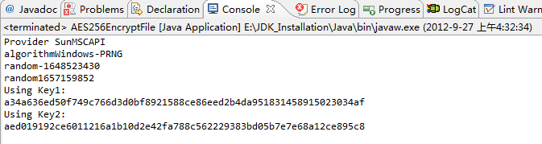
Figure 11

Run it again
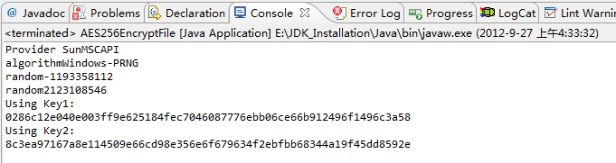
Figure 12

We can see in the figure it is different now.

What we have not solve?

What we have not solve is that we have not find the reason why when using the algorithm "SHA1PRNG", the random number sequence never change if we use the same seed.

